**Technical Report**

Group Name: Group A

Group Members:

* Chaman Ali 15016005
* Chenlei Jie 01318877
* Keith Feeney 15015556
* Surendra Dura 15007669

**Overview**

*This document is submitted in partial fulfillment of the Business Application Development module 2017 delivered by Manuel Tova-Izquierdo.*

Table of Contents

Product Overview 5

Requirements Specification Migration 6

Use Case Diagram 6

Use Case Description 7

Use Case One – Week 4 7

Use Case One – Week 12 9

Reasons for changes: 10

Use Case Two – Week 4 11

Use Case Two – Week 12 11

Reasons for changes: 13

GUI 14

Technical Specification 28

Bootstrap (HTML, CSS) 28

PHP 28

MySQL 28

PHPMyAdmin 28

Self reflective analysis of the initial Gantt chart submitted 29

Discussion on the benefits of using SCRUM 29

Challenges Encountered 30

Conclusion and Future Work 32

# Product Overview

The group is developing a product specifically for OAPs while specialising in those living alone

The aim of the website is to assist in eliciting information, which is provided from a variety of different services in this domain. This will assist in providing the best service and information, based on the customer’s personal needs.

The product itself would not have any new information, as the information would be retrieved from the services and also be available on the service’s own website. The product’s purpose is to bring all these services to one place.

The main users of the product would be the Customer and Company. Admins would also have access.

Customers and Companies can create an account, login, or edit their details from the product. Admins would be able to delete accounts but creating an admin account or logging in would be outside the system.

Companies can add information, services or events, but these must be approved by an Admin before being public. Customers can search information, services, or events (also book events) and save them to a personal area on the website.

Comments can be added by both Customers and Companies, but they must be approved by an admin. Payment for maintaining the site would come from the Company where a small fee would be added to publish information (etc.) to the website.

# Requirements Specification Migration

Use Case Diagram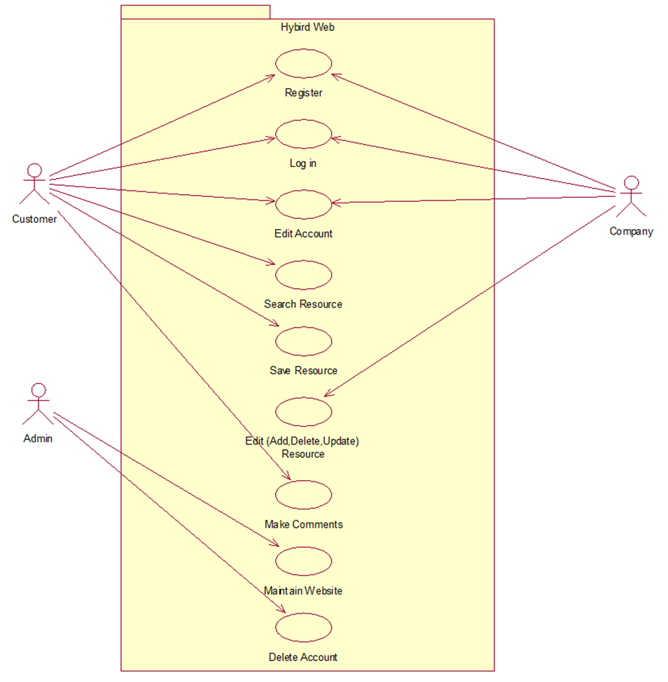

## Use Case Description

### Use Case One – Week 4

Customer Search Resources

**Scope:**

The scope of this use case is for customers search any resources relative to their needs including services and events.

**Description:**

This use case describes the process that how customers search for the resources that they required.

**Flow Description**

***Precondition:***

The system is idle and available.

***Activation:***

The use case starts when customers type in the search box or browsing the website.

***Main flow:***

1. Customers start to search the resource. [A1: From Navbar] [A2: From Search box]
2. List of links which relative to the search topic will showing on the pages, and customers can click the link to get more information.
3. The key words that customers used to search and also the links which are opened will be stored in the history after customer’s log in.
4. The searching resource can be saved by customers to their Favourite.

***Alternate flow:***

(A1: From Navbar)

1. Different categories of services or events will be listed under the Navbar.
2. Customers choose the resources they required.
3. Continue in main flow point 2.

(A2: From Search box)

1. The link pages will not be showing up when customers type the wrong words.
2. The link pages will not be showing up when there are no relative resources.
3. Continue in main flow point 2.

***Exceptional flow:***

The links will not jump to the information pages when the website is being maintained by Admin or when there are too many users browse the website.

***Termination:***

Customer stop searching resources.

***Post condition:***

The system goes to a wait state

### Use Case One – Week 12

Customer Search Resources

**Scope:**

The scope of this Use Case is so users can create a search term on the website and then be redirected to an external site or to search for events on the website.

**Description:**

This use case describes the process that how customers create a search term or search events for the resources that they require.

**Flow Description**

***Precondition:***

The Customer is logged in, and at the Home page.

***Activation:***

The use case starts when customers clicks on Search button on the Home page.

***Main flow:***

1. Customer clicks the Search button.
2. Website goes to ../customersearch/search.php .
3. Customer clicks on Search Events at the bottom on the page. [A1]
4. Website goes to ../customersearch/index.1.php .
5. Customer enters Search term and results appear automatically. [E1]
6. Customer clicks on View Event
7. Website redirects to ../customersaveevent/event.php . Website passes event_id from previous page.
8. Website shows relevant event details on page
9. Customer clicks “Send request” to book for the event.
10. An alert shows up on the screen saying “Request Submitted”

***Alternate flow:***

(A1)

1. Customer enters search term and selects the service they require.
2. Customer clicks Submit button.
3. Website goes to ../customersearch/redirect.php .
4. Page displays confirmation that the Customer was to visit an external site.
5. Customer clicks Yes button.

[Outside system:] Customer is redirected to relevant website’s search page with search term already inserted for them.

***Exceptional flow:***

(A1)

1. No results are found. Customer cannot proceed.
2. Returns to 5 in Main Flow.

***Termination:***

When the customer is redirected to an external site or when the Customer has booked the event.

***Post condition:***

The system goes to a wait state

### Reasons for changes:

The Customer-Search task ran for 8 weeks instead of 5 weeks, due to a personal, internal conflict with one of the Team Members. It was changed to suit their skills and capabilities.

### 

### Use Case Two – Week 4

Company Edit Resources

**Scope:**

The scope of this use case is for companies edit the information of the resources.

**Description:**

This use case describes the process that companies add, delete or update the information of the resources

**Flow Description**

***Precondition:***

The system is idle and available.

***Activation:***

The use case starts when companies edit resources in the manageable page.

***Main flow:***

1. Companies log in to the website (a1 Register).
2. Go to the manageable page and start edit the information of resource.
3. Save the changes for updating.

***Alternate flow:***

(A1 Register)

1. Companies who haven’t log in to the website cannot edit the information of resources.
2. Continue in main flow point 2.

***Exceptional flow:***

The editing will not be process when the web pages are being maintain. And also the changes will not be showed up if the admin not provide the access of the information.

***Termination:***

Companies stop editing the information and save all the changes.

***Post condition:***

The system goes to a wait state

### Use Case Two – Week 12

Company Edit Resources

**Scope:**

The scope of this use case is for companies edit the information of the Events.

**Description:**

This use case describes the process that companies add, delete or update the information of the resources

**Flow Description**

***Precondition:***

The Company is logged in and at the Home page.

***Activation:***

The use case starts when the Company selects the dropdown menu named Company Events and select View/Edit/Delete Events.

***Main flow:***

1. The website goes to ../company_add/showEvent.php .
2. The webpage displays the events that the current logged in Company has created. [No other company’s events are shown here] [A1]
3. The Company selects View/Edit on the relevant event they wish to view or edit. [A2]
4. Website goes to ../company_add/edit.php . Website passes event_id from previous page.
5. Company makes relevant changes and selects Submit [E1]
6. Website returns to ../company_add/showEvent.php .

***Alternate flow:***

(A1)

1. No events are shown [Company has not created any]
2. Terminates / Goes to another Use Case (Add Event, not listed)

(A2)

1. Company selects Delete
2. Website deletes Event.
3. Returns to 2 in Main Flow

***Exceptional flow:***

(E1)

1. Field pattern is not correct (invalid character, null value in required field, etc.}
2. Returns to 4 in Main Flow

***Termination:***

This Use Case terminates when the Company successfully edits or deletes the relevant Event.

***Post condition:***

The system goes to a wait state

### Reasons for changes:

This Use Case was altered to adjust to a Team Member’s capabilities. This Team Member had not used Cloud 9 before and needed to learn this before they could continue, so the allocated time for this task was reduced.

These Use Cases were chosen as these are the most important.

## GUI

1. Customer and Admin Registration Page

This is the registration page for the admin and customer show in the picture.

Week 4 version

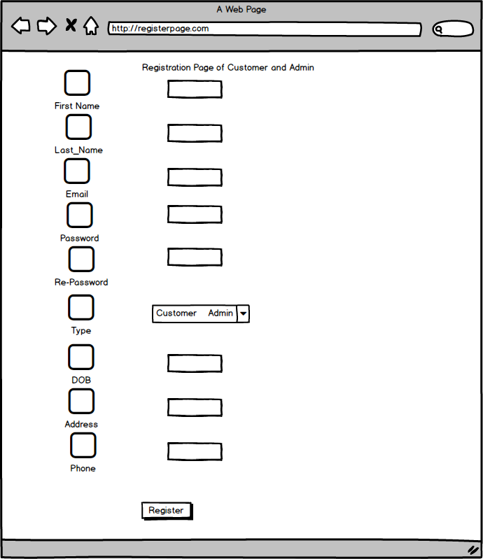

Week 12 Version

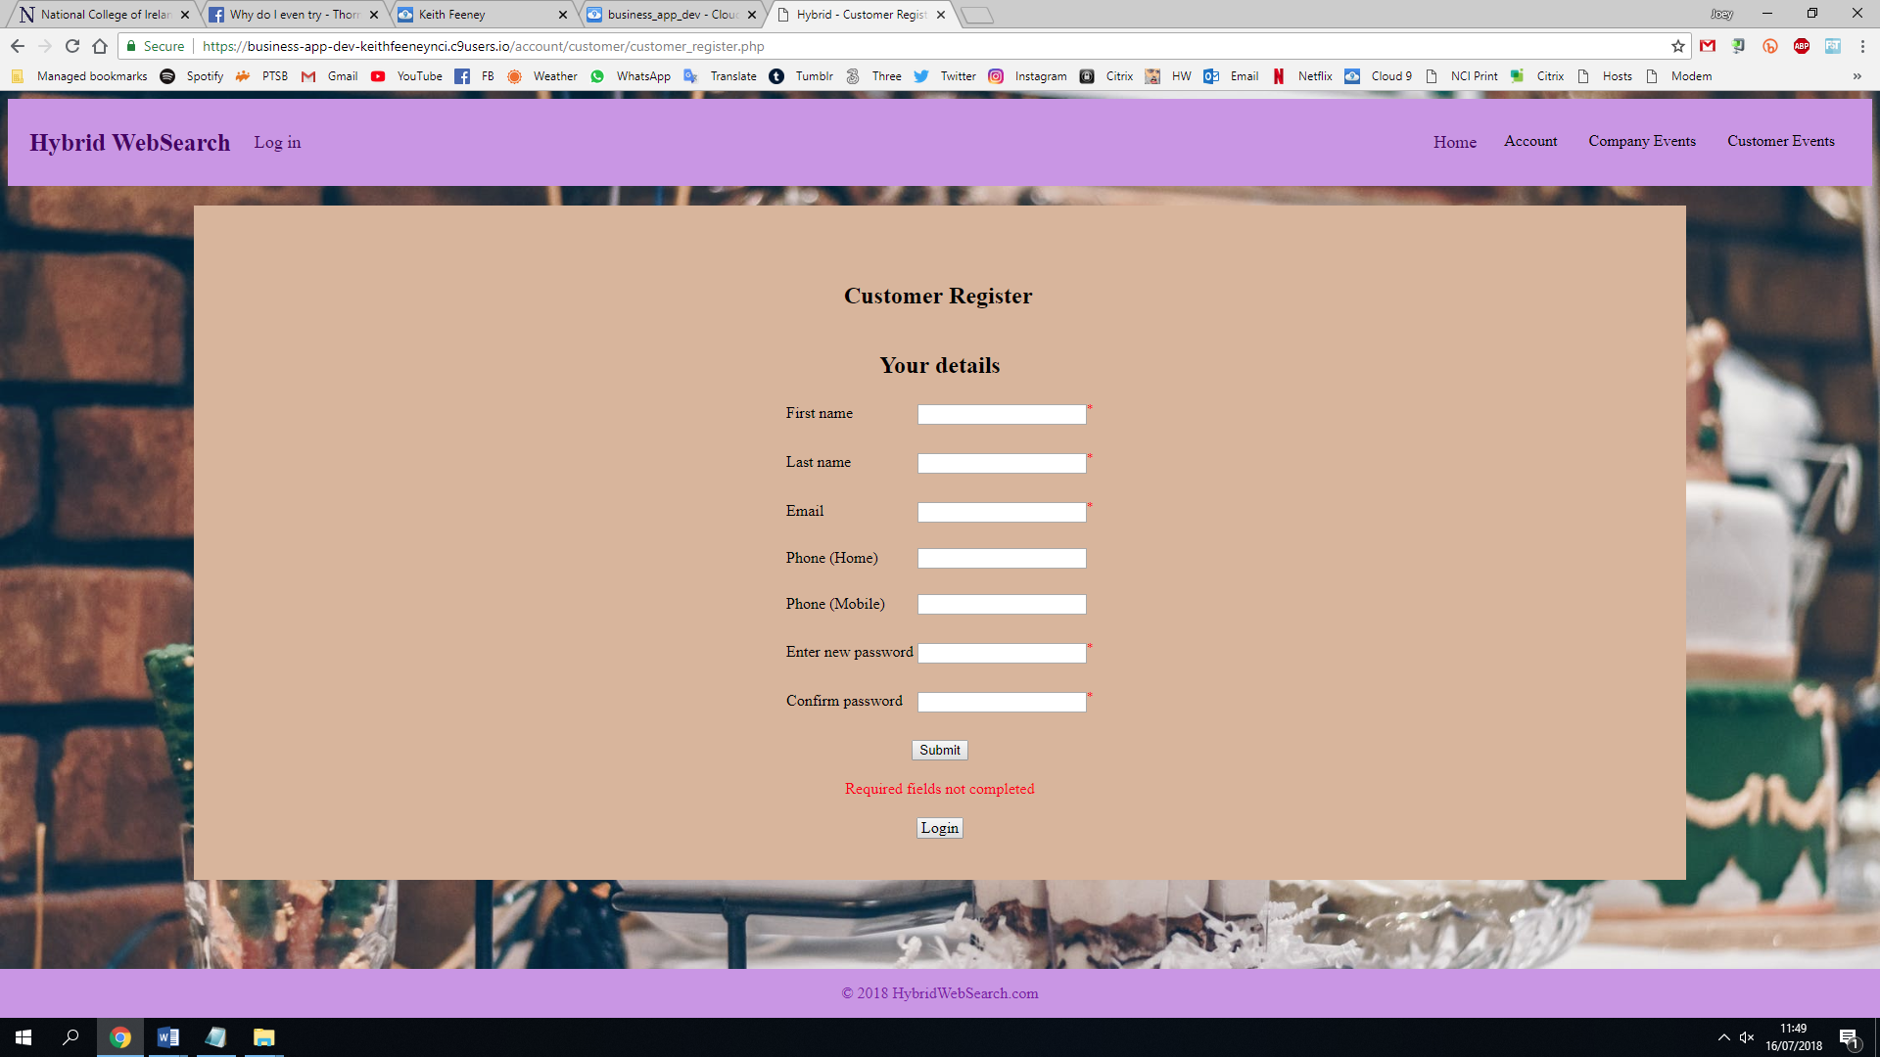

Reasons for changes

The Admin now signs in from an external source, so Admin accounts cannot register/login on the site. This page is also similar to the Company Register but with different fields. An Admin needs to approve an account before it’s activated but this is outside of the system.

Registration Page of Company

This is the registration page of company shown in the picture.

Week 4 version

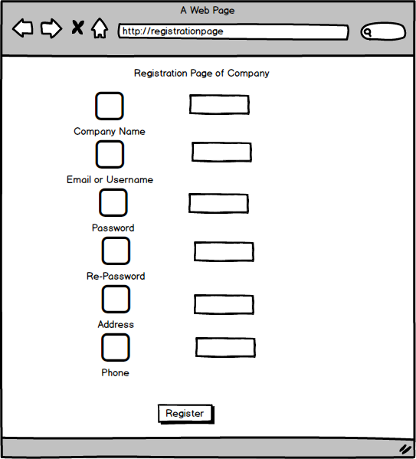

Week 12 Version

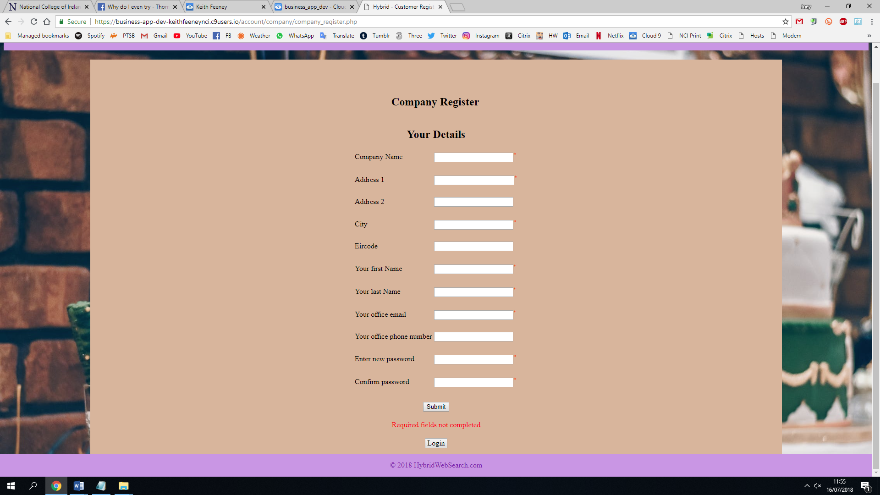

Reasons for changes

Minor changes to fields to make it more usable.

1. Login Page for all users

This is the login page for all the users (Customer, Admin and Company) shown in the picture.

Week 4 version

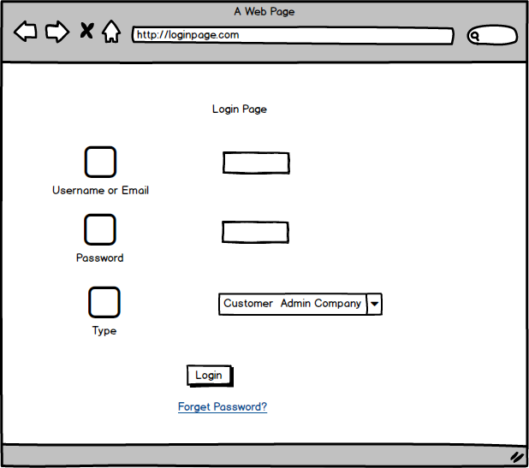

Week 12 Version

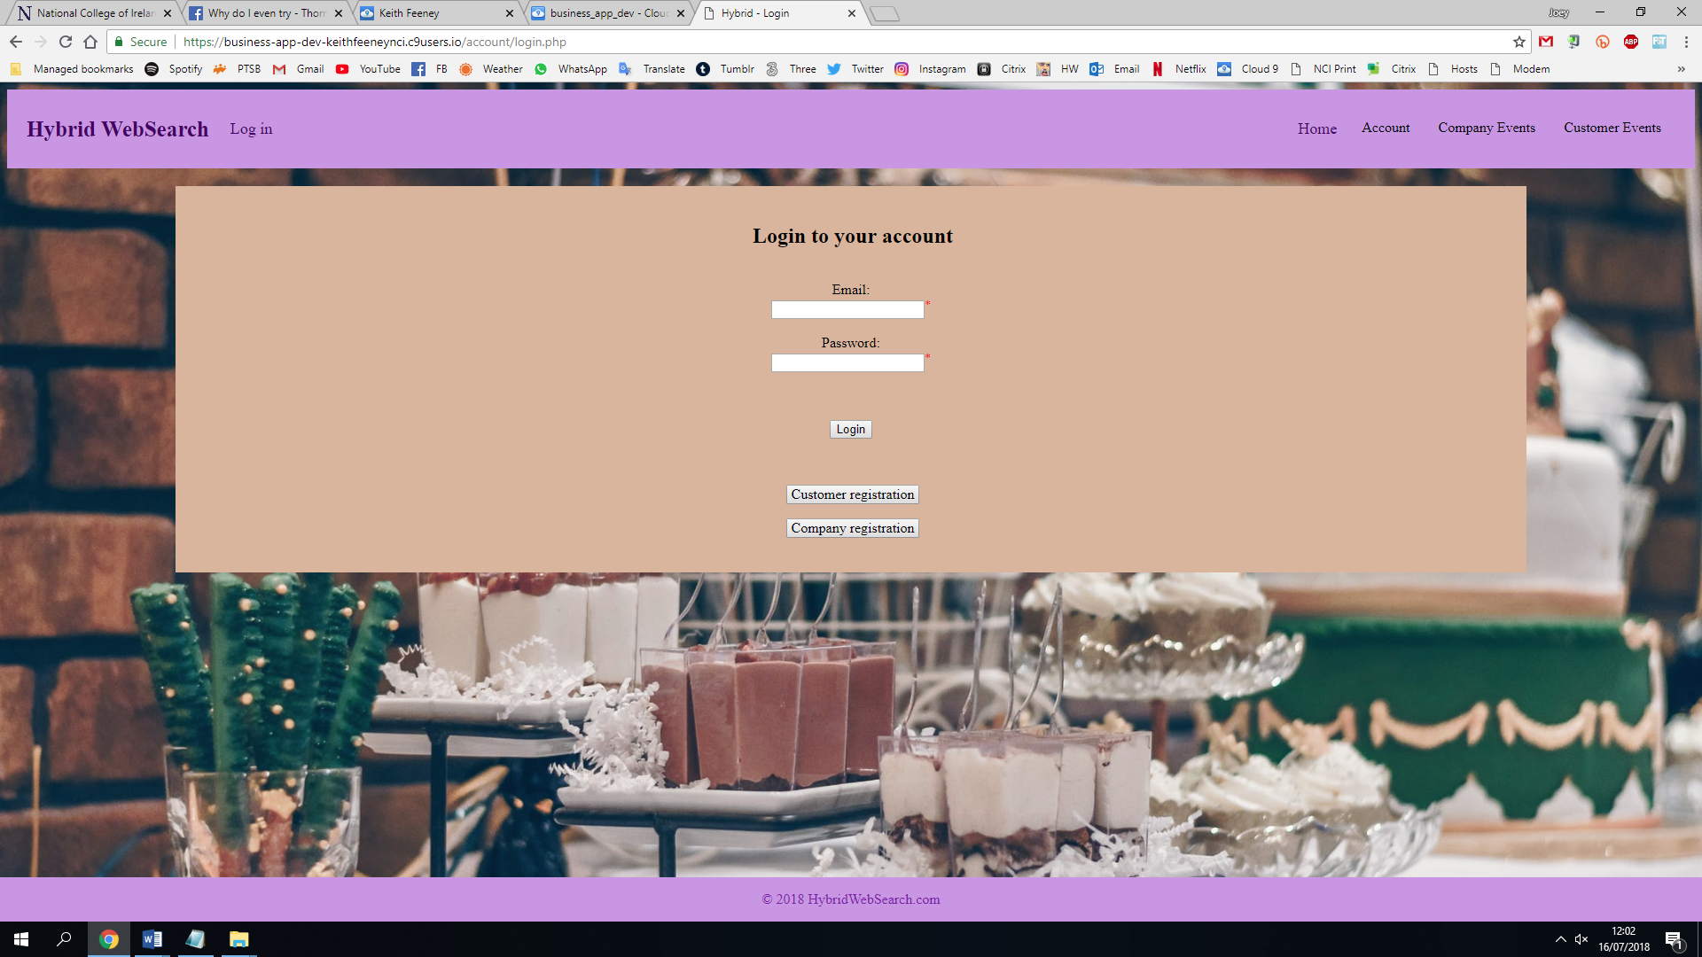

Reasons for changes

No indicator to say whether user is a Customer or Company. This is done in the PHP code. Added options to Register too.

1. Home Page

This is a home page of our website show in the picture which is our first page.

Week 4 version

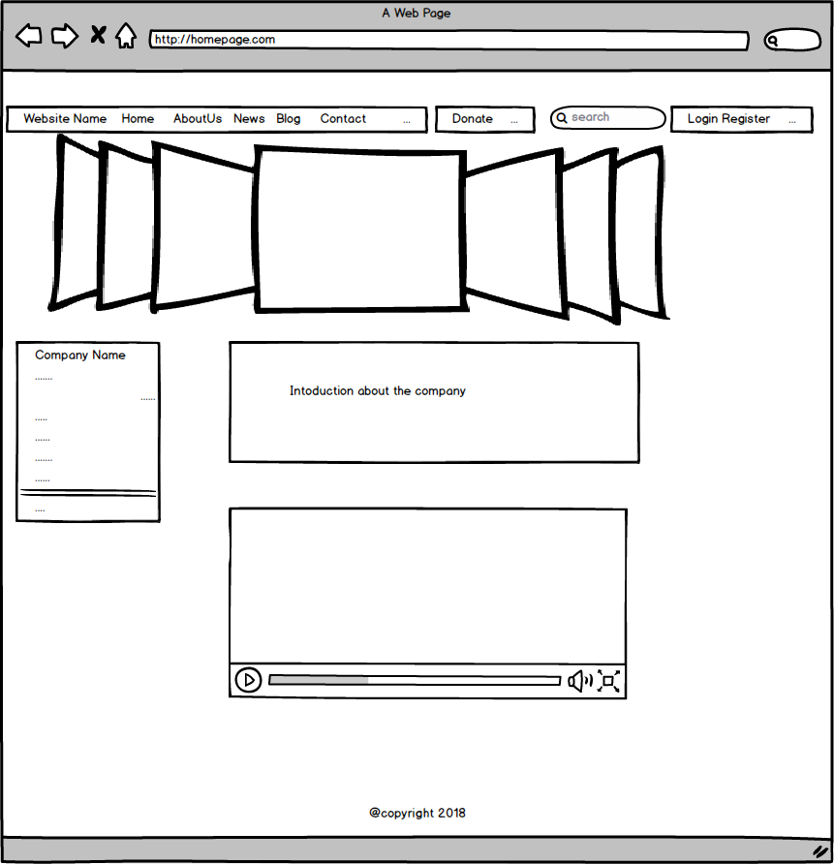

Week 12 Version

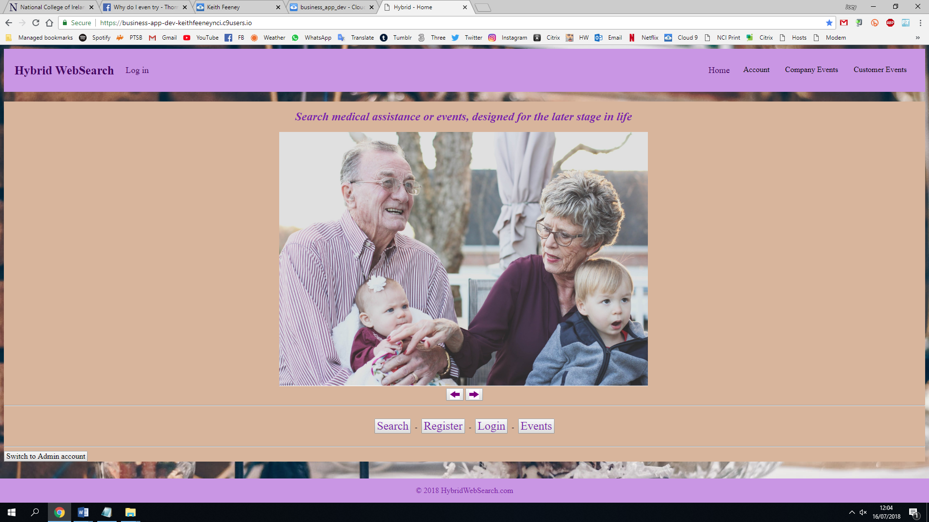

Reasons for changes

No search box at this was too difficult to implement on the header and link it correctly. The image changes every 7.5 seconds. The “Switch to Admin account” button is there for demonstration purposes only and would be removed if this was being given to the client.

1. About Page

This is the about page shown in this picture.

Week 4 version

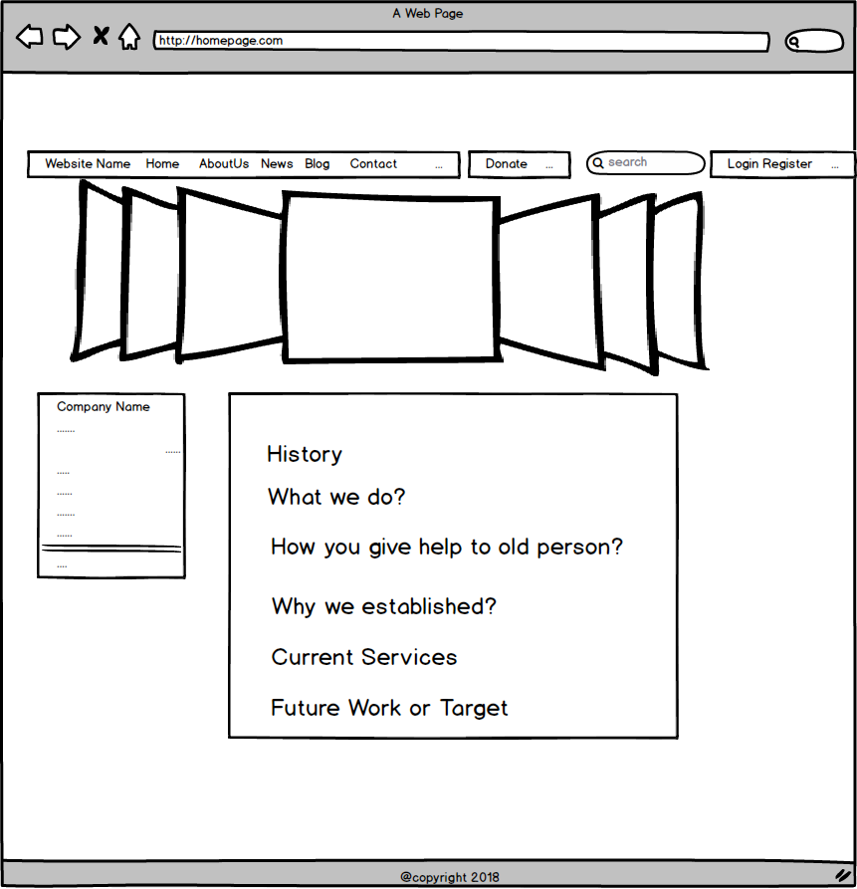

Week 12 Version

Not created

Reasons for changes

An about page is a very general HTML/PHP page. If this was being given to the client, a template would be provided.

1. News Pages

This is the new pages shown in this picture.

Week 4 version

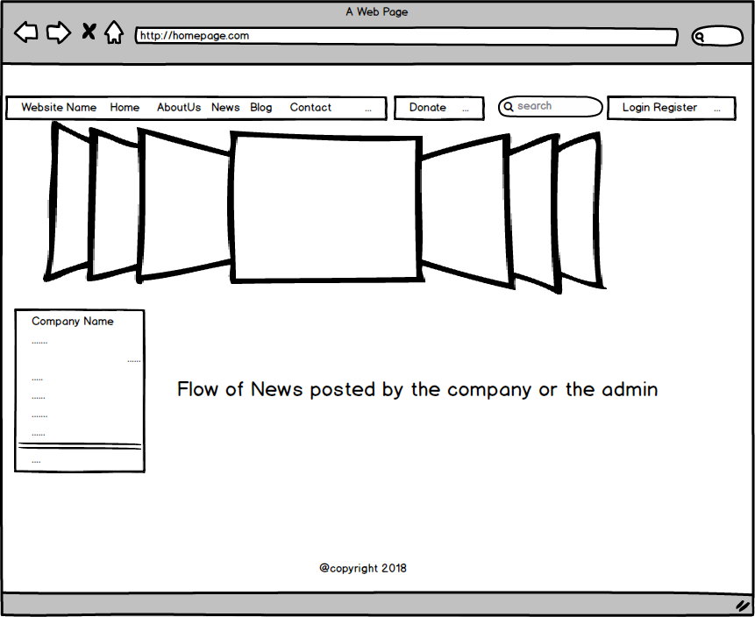

Week 12 Version

Not created

Reasons for changes

Not provided as it was outside the scope of the project.

1. Blog Page

This is the blog page shown in this picture.

Week 4 version

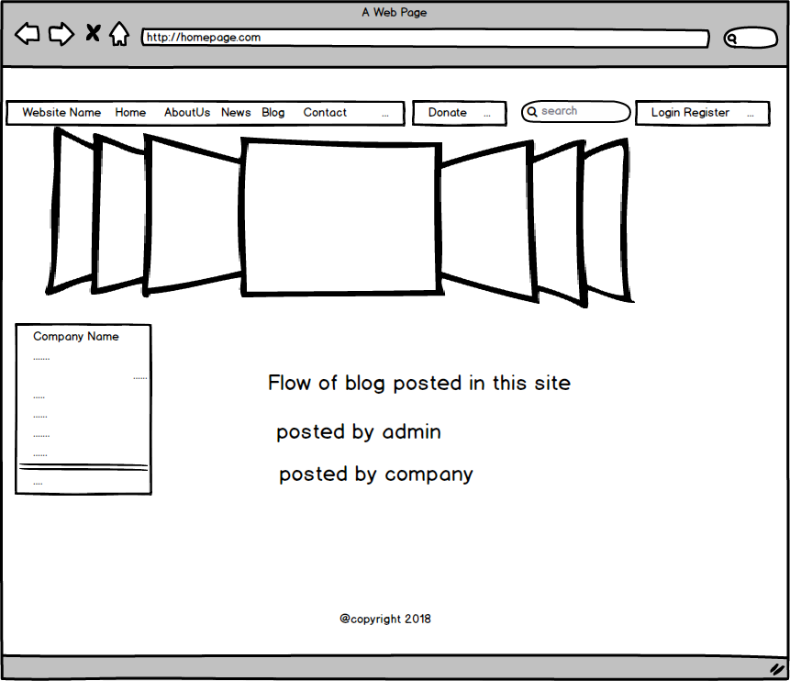

Week 12 Version

Not created

Reasons for changes

Not provided as it was outside the scope of the project.

1. Contact Page

This is the contact page shown in this picture.

Week 4 version

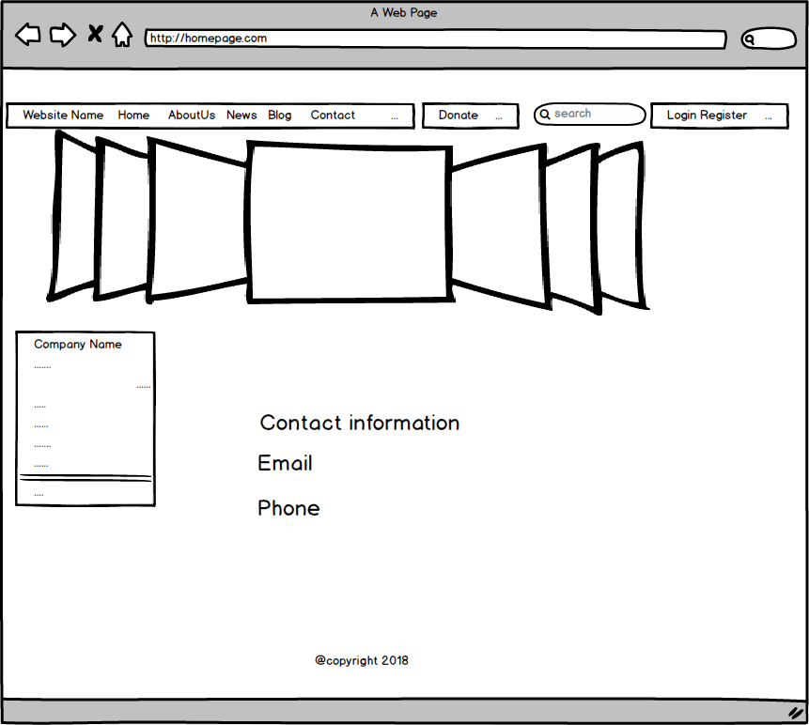

Week 12 Version

Not created

Reasons for changes

An contact page is a very general HTML/PHP page. If this was being given to the client, a template would be provided.

1. After Login Home Page

This is the after login home page shown in the picture.

Week 4 version

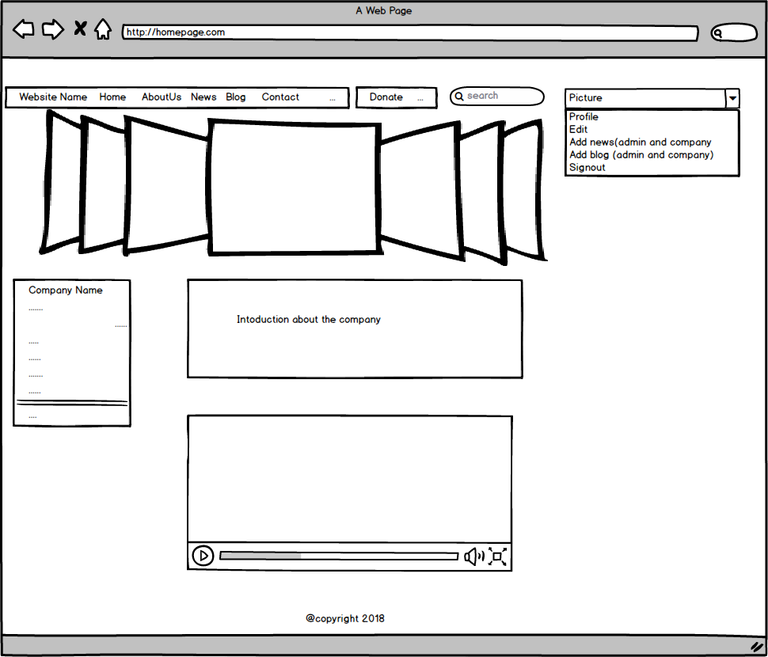

Week 12 Version

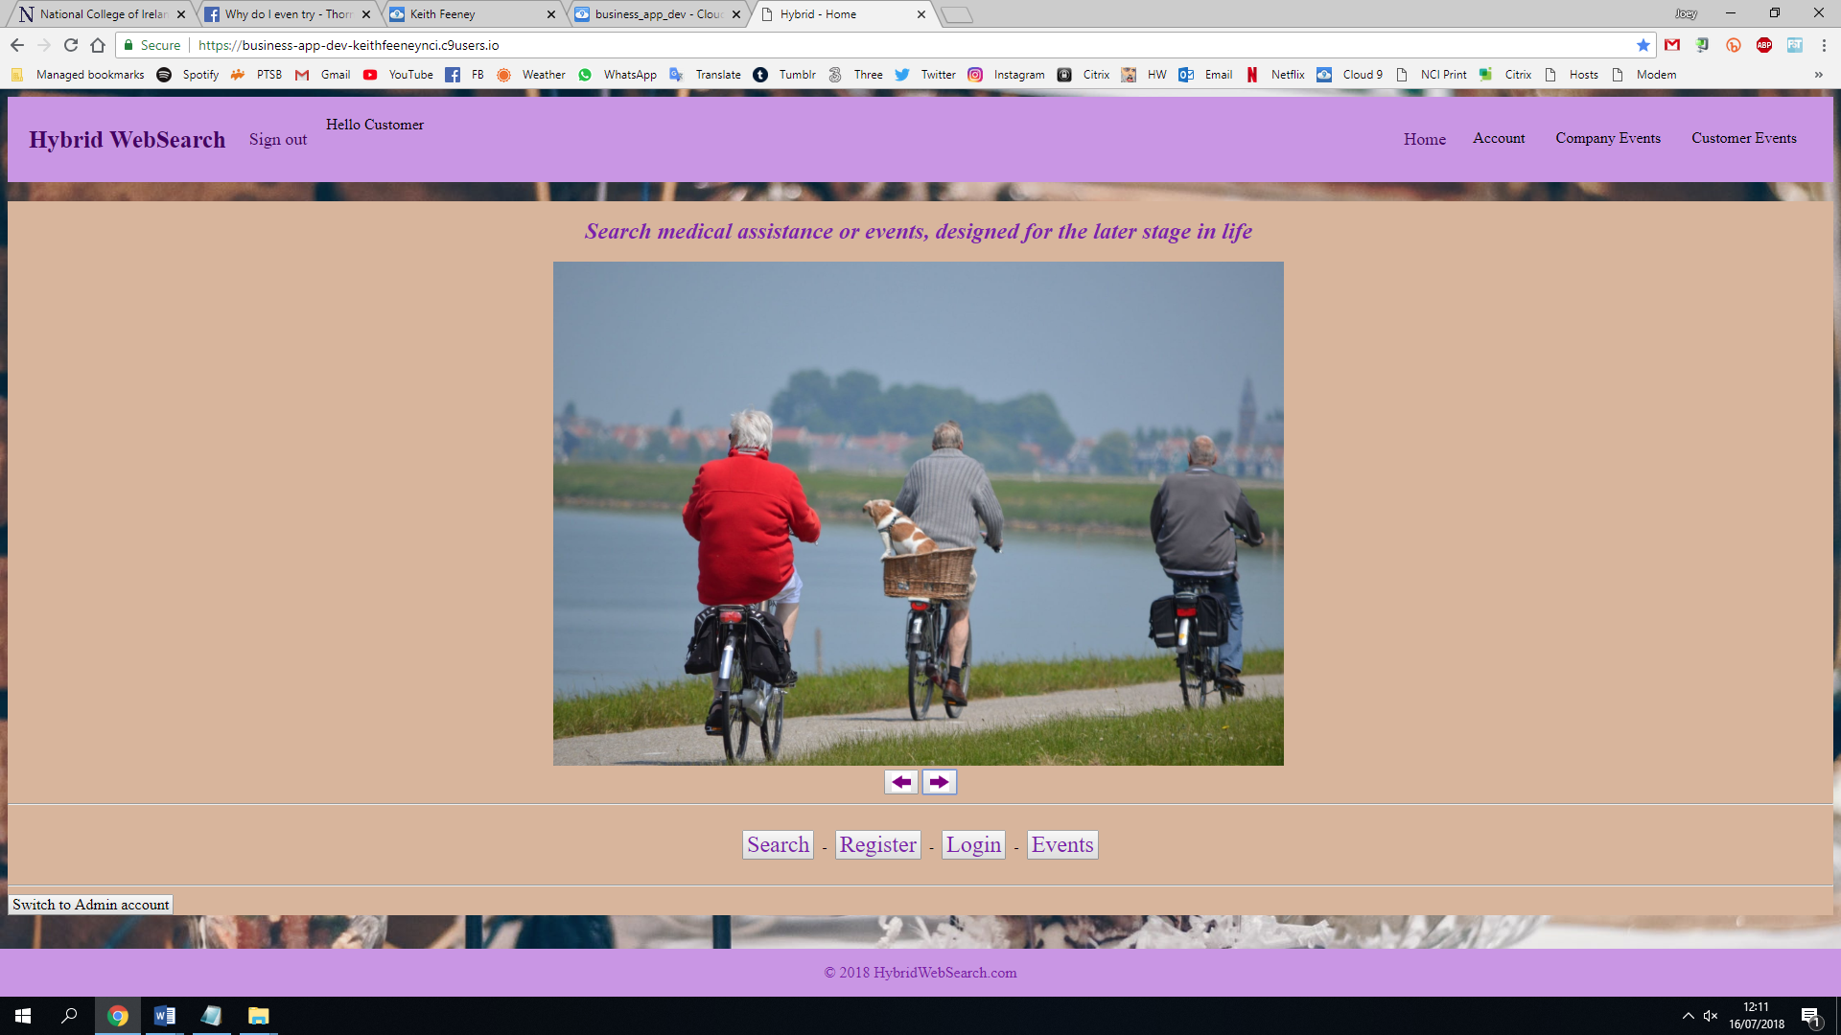

Reasons for changes

In the header, the Log in button is changed to Sign out, it also has Hello First_Name.

## Technical Specification

[Green denotes changes]

Our project website would include a wide range of technologies to work and run properly, so we are using Bootstrap, HTML, CSS, JavaScript, PHP and MySQL.

### Bootstrap (HTML, CSS)

Bootstrap is affective front-end framework which could be used with HTML5 and CSS to build responsive websites or applications. We will use Bootstrap so that our application could work easily on all phones, tablets and desktops. Bootstrap is very good when it comes to mobile useable websites. Bootstrap has no limitation over the use of browser so there would be no problem when we run our website on any browser whether it is on mobile, tablet or desktop.

We would use Bootstrap forms for the companies and users who could easily register themselves and find the right choice for them to get the services. Bootstrap will work as our front-end or User—end view.

### PHP

PHP is Server-side scripting language. We would use PHP to create, update or delete or closing the files on the server side. We will use it one back-end. We would create dynamic content to put on the Bootstrap created pages. We will use PHP scripts to control the user’s access to the website. We will use PHP as security of the website as well. We will integrate PHP with MySQL which will our database to store data on the server so we could use PHP to restore, delete or even update data from the server. PHP is able to contain text, HTML, CSS, JavaScript and PHP code.

### MySQL

We will mainly use MySQL to get data from the user through Bootstrap forms as registration page. We would save this incoming information in MySQL over a server and when the user will try to log in then this MySQL database will match that info with info present on the database then it will let the user to get into website with the access to connect with companies and charities present on the website. We would be able to update, delete and create data whenever needed. Companies and charities data would be saved on our server in MySQL.

Bootstrap, PHP and MySQL including HTML, CSS and JavaScript will be integrated with each other to make a website which would be working fully at any browser and any device with full capabilities.

### PHPMyAdmin

PHPMyAdmin was also used to view the MySQL tables in the browser to edit some information. Cloud 9 has PHPMyAdmin built-in.

**[20% of Marks]**

# Self reflective analysis of the initial Gantt chart submitted

The project was achieved basically according to the timeline of the initial Gantt Chart. The Team Member who was doing each task for every week is different of the initial task. That is because the group decides who is in charge of which task is completed in every sprint weekly meeting depending on their preference and ability.

Some of the names of the tasks are changed in order to make the task unambiguous for the main function. Such as the tasks in week 4, the group changed the Customer-Add to company Add. The reason why the group are doing this is because the group didn’t specify the user type in the beginning of doing the initial Gantt Chart. The group actually have three user types which are customer, company and admin. And for the task in week4, the group need to do the task for company to add the events into the website. So the group changed the name in order to clarify the main function. At the same time, the group changed all the customer to the specified name for the rest of week. For example, in week5, the task customer-log in/register has been changed to user-log in/register in order to complete the section of all three types of user can use the website.

Some of the tasks may not get finished during the allocated time, but the group still following the initial Gantt Chart to complete the new task for the new week and continue doing the uncompleted tasks in our spare time. So the group would not be too behind the schedule. **[30% of Marks]**

# Discussion on the benefits of using SCRUM

**While completing our project we got the some of the benefits by using SCRUM model which are as follows:**

1. **Completed in time:**

We do every week sprint cycle and meeting up to 8 weeks. From this process, we got benefit is that we completed our project at a time because we divide the time for each section of our project and divide it to the four group members which was look out by scrum master and the product owner.

1. **Increase collaboration and ownership in the team:**

While using Scrum, we did meeting every week and find out the problem and help each other to solve did. Also, the time slot helps us to completed our part at the particular time. We also know each other work how far the done and what we have to add more to get a better result.

1. **Easily completed the project:**

Scrum help us to completed our project easily because by watching our burn down chart or grant chart, we can track our progress and help us to completed our project.

1. **Better final product:**

Scrum help us to give us satisfied final product for us because what we made in our burn down chart, we completed on our project. On the other hand, we did not face problem on the last stage like some code isn’t working or some part having error on our project.

**[20% of Marks]**

# Challenges Encountered

While working as a group, the group faced many issues regarding coding and research. At first, the group faced issues with two of our group members, who was not familiar with Cloud9 framework and phpMyAdmin database framework. They managed to overcome this issue after watching some tutorials on YouTube and Google. The group faced issues while creating login and signup pages because the password encryption coding was making the code very messy, so any other member cannot even understand this piece of code easily. So, the group tried to search for an alternative and the group found one. It was AES_ENCRYPT in MySQL. At first it was creating issues when the group tried to verify the password but later, the group managed to fix it after some research. The group had an issue when the group have two separate pages for login Customer login, Company login. The group got some issue there while fetching the email data from both tables. But after getting help from Stack Overflow the group fixed it. One of our group member was having issues in fetching the online data from the health services Ireland and the hospitals here as well. The group managed to get rid of errors by collaborating with the team and was able to fetch all the data required for the page.

The group managed to fix the code of one of our member who was having issues with connection of the database with page, so she was unable to fetch the data from company page. After some research on internet and websites the group were able to fix them. She got issues in company side edit button because the edit button was not working as expected. As she was not very familiar with PHP coding that’s why she was stuck there but after some research on the specific coding she overcome the issues and get them fixed. One of our member got coding issues in event page because customers were unable to register themselves for the specific event. After doing some research on YouTube, Google and W3School, he managed to fix this issue and told the group about it.

The group got the issues with cookies as the group were using the cookies for the first time. The group were trying to keep the cookies save until the browser was open and after that the group want them to be erased. The group got issues by doing this but after some research on internet the group overcome this issue and cookies are working fully as expected. The group got a main issue with the Admin Login because admin is not supposed to be logging in into the website through customer login section, so the group put the admin login button on the home index page, so admin can switch to admin mode anytime. But this admin login button won’t be visible if the group launch the website on the internet anytime.

**[20% of Marks]**

# Conclusion and Future Work

The group would hope that this website could be implemented into other countries and languages. More services could also be added, as well as more events and event groups. A partnership with governments, investors or old-age pensioner groups (such as Age Action Ireland) would also be a huge benefit.  **[10% of Marks]**